­­­

LOGO 3

**3- BIOSTRATIGRAPY**

**Qualitative and quantitative biostratigraphic analysis of eleven microfossils groups; high resolution age-dating, paleobathymetric, paleoenvironmental, paleoecological, paleocliamtological interpretation using abundance and diversity variations of environmentally sensitive microfossils. Construction of high-accuracy first/last occurrence, abundance, and diversity diagrams and chrononstratigrphic charts and using results in graphic correlation (composite standard) studies. Palynofacies analysis & vitrinite reflectance analysis for guidance in paleoemvironmental interpretation and kerogen type identification. Well site stratigraphy and absolute age- dating through isotope studies and paleomagnetic studies of oriented samples.**

**1-STRUCTURAL INTERPRETATION**

**Complete structural assessment & interpretation starting from outlining structure from remote sensing, gravity, magnetic, & seismic data to integration with structural observation from well & outcrop data. Definition of 3D structural modes and outlining the effect of structures on facies distribution and migration pathways to define traps.**

**2- FAULT SEAL ANALYSIS & TRAP INTEGRITY**

**Complete fault seal analysis & trap integrity evaluation starting from structural, facies, & petrophysical modeling to analysis of reservoir juxtaposition possibilities and shale Gouge Ratio (SGR) analysis and shale smear sealing potential. Evaluation of trap integrity starting from well location to propagating results into 3D model.**

HIGH END E & P SERVICES

1. GEOLOGICAL SERVICES

Our staff of structural geologists has worked in complexly deformed areas throughout the world, solving geological problems. Our geological interpretation techniques allow us to be better than other in defining structures that favorable to hydrocarbon accumulations.

GAS & OIL TECHNOLOGY

“G.O.T”

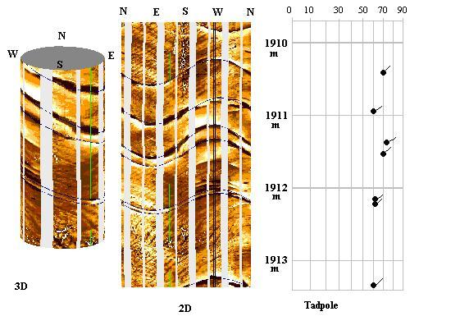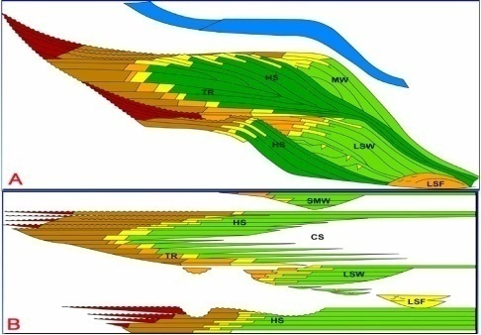

**4- SEDIMENTOLOGY**

**Core description, laser-particle grain size analysis, petrography, well-log motif and mineralogical content interpretation for depositional paleonvironments, diagnostic history, and reservoir quality interpretation. Standardized lithological classification of rock samples using ternary diagrams based on mineralogical content & percentages. Grain size distribution analysis and determination of lithofacies and association, including ichnofacies interpretation. Scanning Electron Microscope (SEM) and x-ray Diffraction (XRD) analysis. High resolution seismic sedimentology, geomorphology, and stratigraphy.**

**Conditioning results for use in integrated sequence stratigraphic studies. Seal effectiveness studies through thin section, SEM, XRD, laser particle size distribution studies, and capillary pressure analysis of seal rocks.**

**5- HIGH-RESOLUTION SEQUENCE STRATIGRAPHY**

**We do detailed sedimentology and biostratigraphy within sequence stratigraphic framework, integration of core, well log, and outcrop data whenever available, and integration with seismic sequence stratigraphy. Sequence and parasequence definition up to fifth order. Local chronostrtigraphic chart construction, depositional and paleogeographic history interpretation leading to predicting petroleum system elements ahead of drill bit.**

**6- FMI INTERPRETATION**

**We provide a detailed static and dynamic image log interpretations through structural dip & azimuth analyses and lithofacies interpretations. Dip and azimuth analysis include manual dip-picking and structural dip removal, depositional dip interpretation, and sedimentary structure & texture interpretation. Paleocurrent analysis & dip classification is also carried out with high detail (e.g. true dip magnitude & azimuth “bed boundaries”, lamination boundaries “structural dip”, fault planes, and depositional dips). Statistical representation of dip and azimuth by rose diagrams and histograms. Observations & analysis are used for interpretation of structural elements and depositional paleoenvironment.**

**7- GEOCHEMISTRY**

**Source rock evaluation and hydrocarbon characterization (source & environment of deposition, hydrocarbon maturity, oil-oil correlation, oil-reservoir extract correlation, & oil-source rock extract correlation). Formation water characteristics and organic richness ( organic carbon”TOC” & source potential “S2 “). Kerogen type (hydrocarbon generating potential “hydrogen index-Hi). kerogen type based on hydrogen index. Maturity from vitrinite reflectance ( immature, oil window, & gas window). Migrated hydrocarbons (transformation ratio “S1 /S2). Evaluating source potential migrated hydrocarbon potential.**

Delete text and place photo here.

Delete text and place   
photo here.